# HTML 5

### INTRODUCTION

* Most enhanced version of HTML which is neither a programming language but a markup language.
* Latest features that have been added up to make it a modern website is
  + Semantic Elements like <header>, <footer>, and <section>.
  + Forms 2.0 that brings improvements to HTML web forms where new attributes have been introduced for <input> tag.
  + WebSocket − A next-generation bidirectional communication technology for web applications.
  + HTML5 introduces events which flow from web servers to the web browsers which are named as Server-Sent Events (SSE).
  + Canvas is a two-dimensional drawing surface that you can program with JavaScript.
  + Audio & Video − You can embed audio or video on your webpages without resorting to third-party plugins.
  + Geolocation − Now visitors can choose to share their physical location with your web application.
  + Microdata − This lets you create your own vocabularies beyond HTML5 and extend your web pages with custom semantics.
  + Drag and drop − Drag and drop the items from one location to another location on the same webpage.

### SYNTAX

DOCTYPE :-

HTML had longer doctype definitions because it was SGML(Standard generalized markup language) based hence it required reference to document type definitions.HTML 5 on other hand uses simple syntax to specify DOCTYPE which is f <!DOCTYPE html>

CHARACTER ENCODING :-

We can simply specify character encoding as <meta charset = "UTF-8">

SCRIPT TAG:-

HTML 5 has reduced extra information given in previous versions of HTML for script tag. We can define it simply as follows without giving <script type = "text/javascript" src = "scriptfile.js"></script> which was the conventional method followed. We can define it simply <script src = "scriptfile.js"></script>. The same modification has happened with <link> tag too. We can link other stylesheets using syntax as follows :- <link rel = "stylesheet" href = "stylefile.css">.

DOCUMENT :-

* section − This tag represents a generic document or application section. It can be used together with h1-h6 to indicate the document structure.
* article − This tag represents an independent piece of content of a document, such as a blog entry or newspaper article.
* aside − This tag represents a piece of content that is only slightly related to the rest of the page.
* header − This tag represents the header of a section.
* footer − This tag represents a footer for a section and can contain information about the author, copyright information..
* nav − This tag represents a section of the document intended for navigation.
* dialog − This tag can be used to mark up a conversation.
* figure − This tag can be used to associate a caption together with some embedded content, such as a graphic or video.

**Example 1**

<html>

<head>

<title>

First example

</title>

</head>

<header>

<h1> HTML5 Document Structure Example</h1>

<p> This page is my frist web page in this journey with REVER</p>

</header>

<nav>

<ul>

<li>Click here to view internship details</li>

<li>Click here to submit your application</li>

<li>Click here to contcat REVER_Tech IT SOLUTIONS</li>

</ul>

</nav>

<footer>Created by Team Rever</footer>

</html>

**OUTPUT**

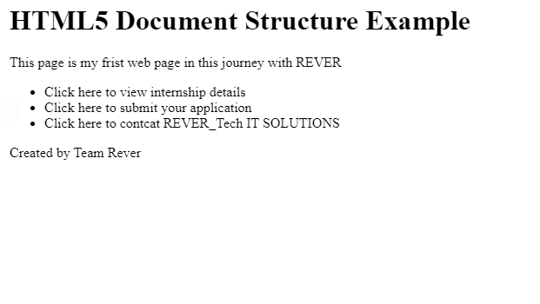

### ATTRIBUTES

A new feature being introduced in HTML 5 is the addition of custom data attributes which starts with data- and would be named based on your requirement.

Eg:- <div class = "example" data-subject = "physics" data-level = "complex"> … </div>. Their values can be received using Javascript APIs or CSS.

### WEB FORMS

HTML4 input elements use the type attribute to specify the data type.HTML4 provides following types −

|  |  |
| --- | --- |
| **Type** | **Description** |
| text | A free-form text field, nominally free of line breaks. |
| password | A free-form text field for sensitive information, nominally free of line breaks. |
| checkbox | A set of zero or more values from a predefined list. |
| radio | An enumerated value. |
| submit | A free form of button initiates form submission. |
| image | A coordinate, relative to a particular image's size, with the extra semantic that it must be the last value selected and initiates form submission. |
| textarea | A free-form text field, nominally with no line break restrictions. |
| button | A free form of button which can initiates any event related to button. |

Apart from the above-mentioned attributes, HTML5 input elements introduced several new values for the type attribute. These are listed below.

|  |  |
| --- | --- |
| datetime | A date and time (year, month, day, hour, minute, second, fractions of a second) encoded according to ISO 8601 with the time zone set to UTC |
| datetime-local | A date and time (year, month, day, hour, minute, second, fractions of a second) encoded according to ISO 8601, with no time zone information. |
| date | A date (year, month, day) encoded according to ISO 8601. |
| month | A date consisting of a year and a month encoded according to ISO 8601. |
| time | A time (hour, minute, seconds, fractional seconds) encoded according to ISO 8601. |
| email | It accepts only email value. This type is used for input fields that should contain an e-mail address. If you try to submit a simple text, it forces to enter only email address in email@example.com format. |

<OUTPUT> element :-

HTML5 introduced an element <output> which is used to represent the result of different types of output, such as output written by a script.

### INSERTING IMAGES

By using <img> tag we can insert any image in your web page.

**Example 2**

<!DOCTYPE html>

<html>

<head>

<title> Rever Dreams</title>

</head>

<body>

<p> Inserting an image</p>

<img src = "https://github.com/lakshmi-19/Rever_Dreams/blob/main/tree-736885__480.jpg" alt = "Image" />

</body>

</html>

Set Image Width/Height

**Example 3**

<!DOCTYPE html>

<html>

<head>

<title>Width and Height</title>

</head>

<body>

<img src = "https://www.google.com/search?q=images&rlz=1C1CHZL_enIN717IN717&sxsrf=ALeKk00-mvH_rNUYPETarELbDfjb-SUHUQ:1626011401515&source=lnms&tbm=isch&sa=X&ved=2ahUKEwjWrfO_lNvxAhXS63MBHXH_DLAQ_AUoAXoECAEQAw&biw=1366&bih=657#imgrc=L8xfQakH9a8tJM" alt = "Image" width = "150" height = "100"/>

</body>

</html>